**S-View User Manual**

**1. Software Startup & Activation**

1. Double-click S-View.exe
2. First-time launch will pop up the activation window
   * Copy the displayed **Machine Code** and send it to Arthur Gu

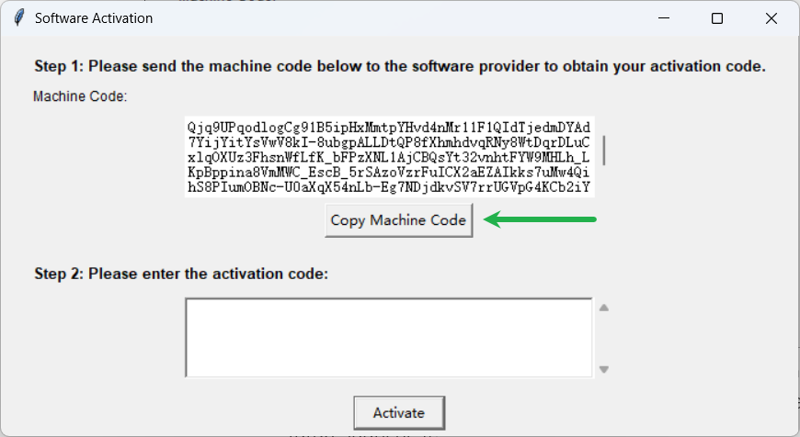

* + Arthur to generate the **Activation code**
  + Paste the **Activation code** you receive into the large text box below

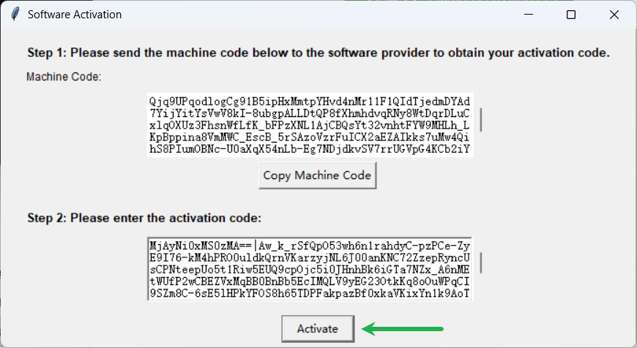

* + Click **Activate** → The software will enter the main interface (After successful activation, a license.json file is created and will be verified automatically on future launches)
  + Ensure that license.json and S-View.exe remain in the same folder. Do not delete license.json under any circumstances.

**2. Main Interface Overview**

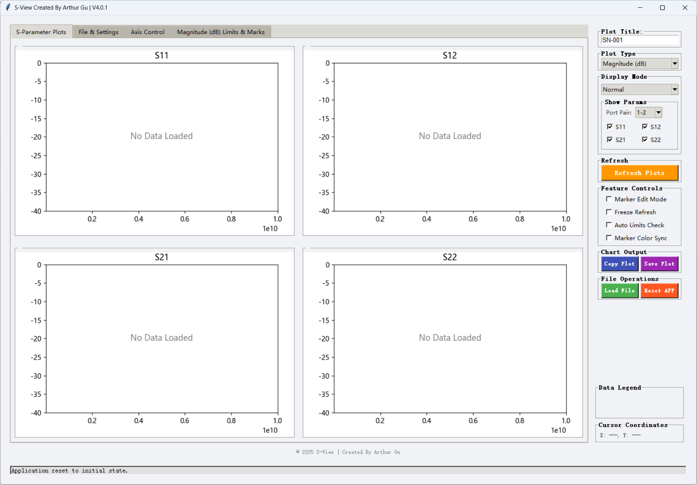

**3. Quick Start**

**3.1 Load Files**

1. Click **Load File** (bottom-left)

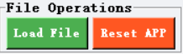

1. Select one or multiple .s2p / .s3p / .s4p files

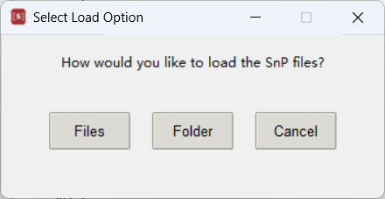

1. In **File & Settings** showing each file is automatically assigned an ID (1, 2, 3…) and a unique color

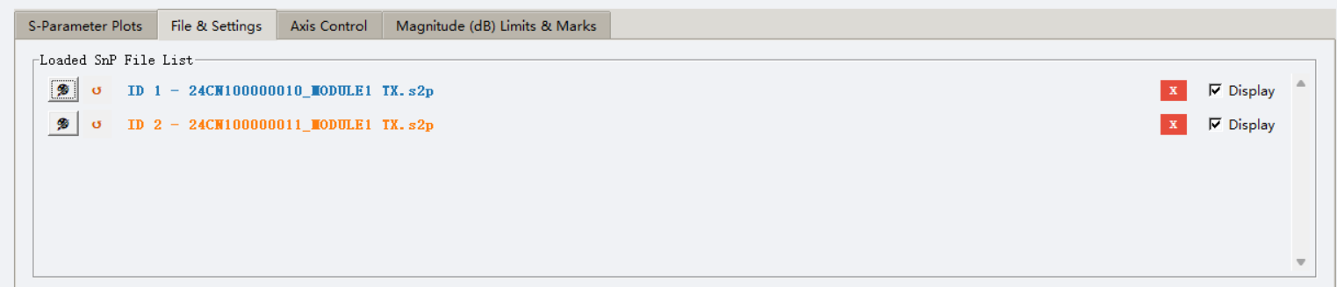

**3.2 Data Summary**

* After the SnP file is loaded in **Normal Mode**, the **Data Summary** area will display the same ID color as shown in the **File & Settings** list, and will also display the file’s number of points.

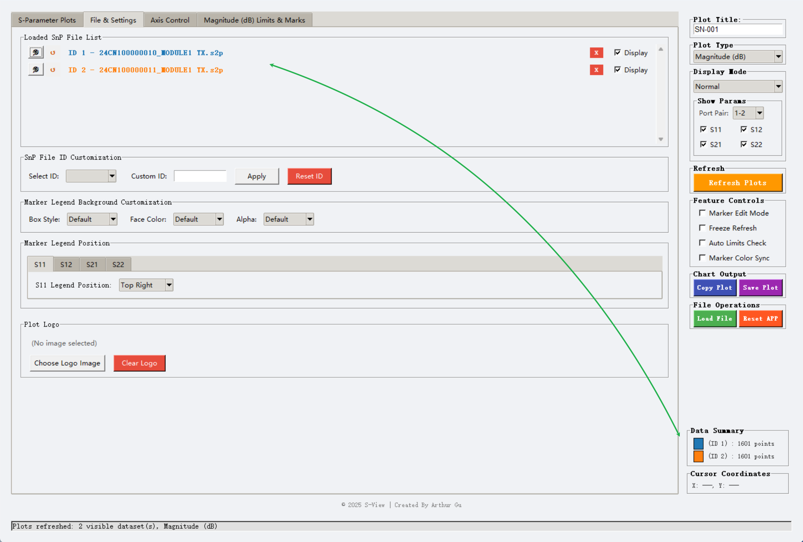

**3.3 Switch Between Three Plot Type**

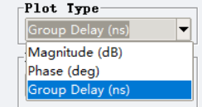

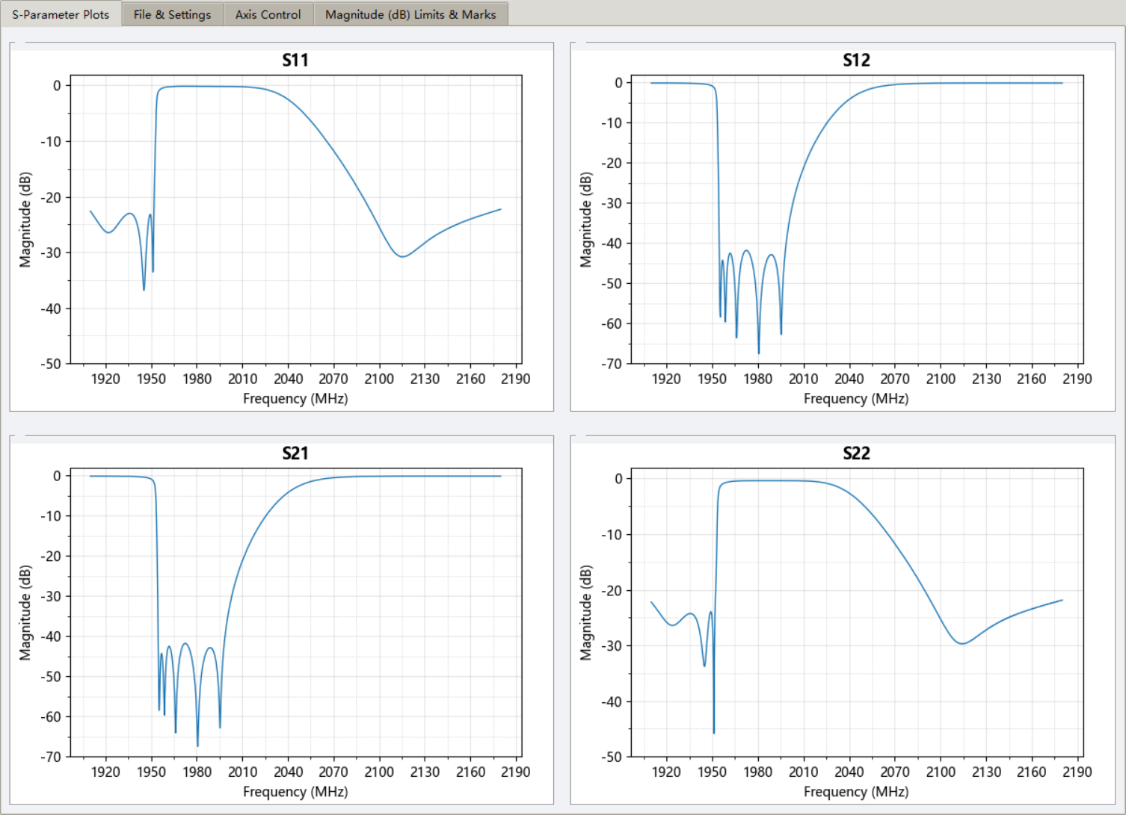

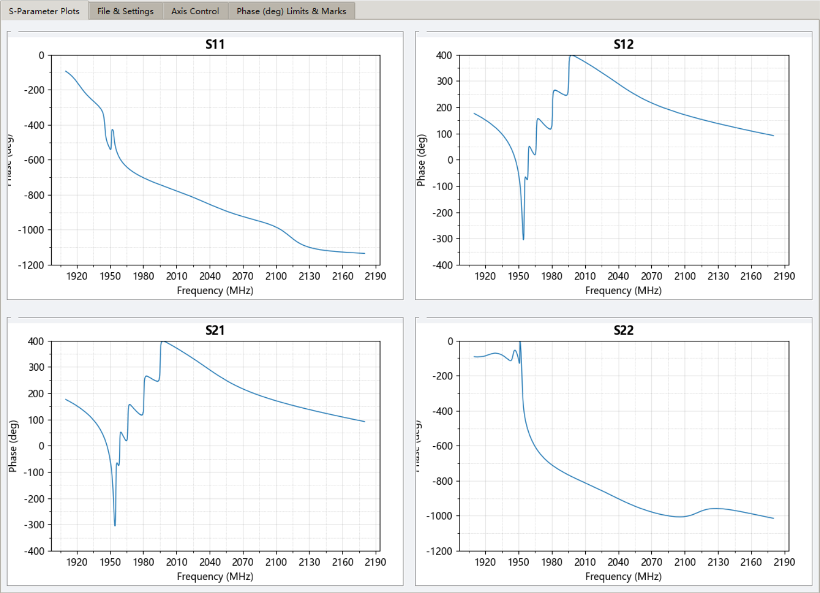

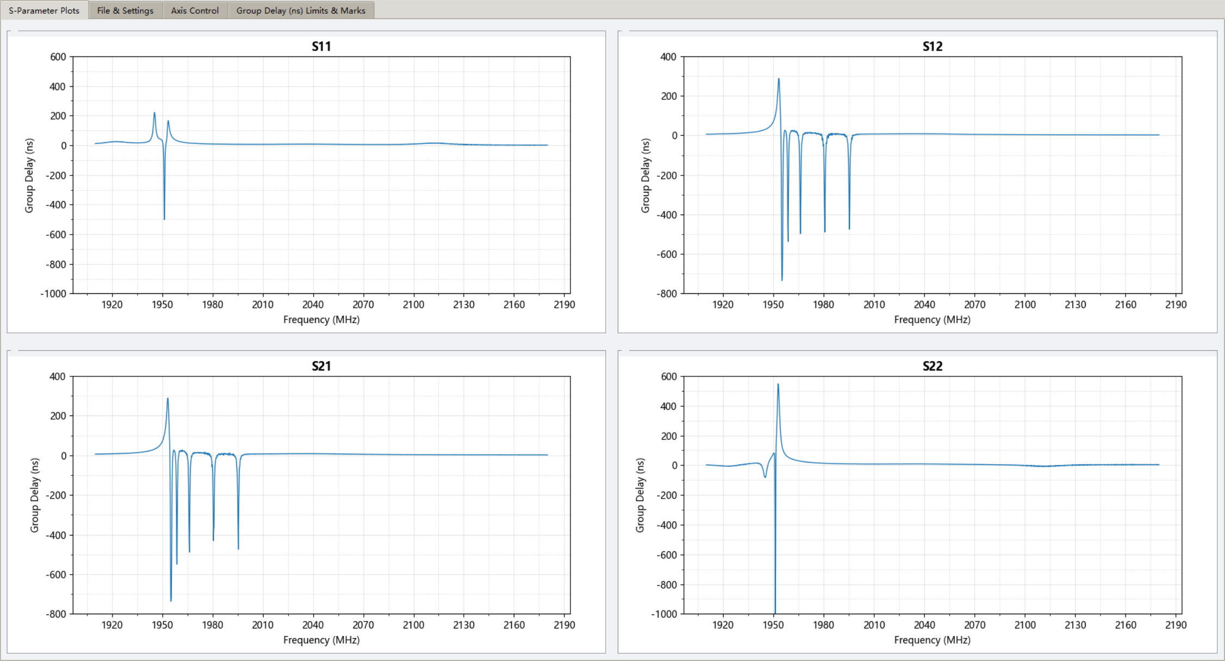

**3.4 Switch Between Two Display Modes**

* **Normal Mode** (default): Classic 2×2 grid, ideal for viewing each parameter independently

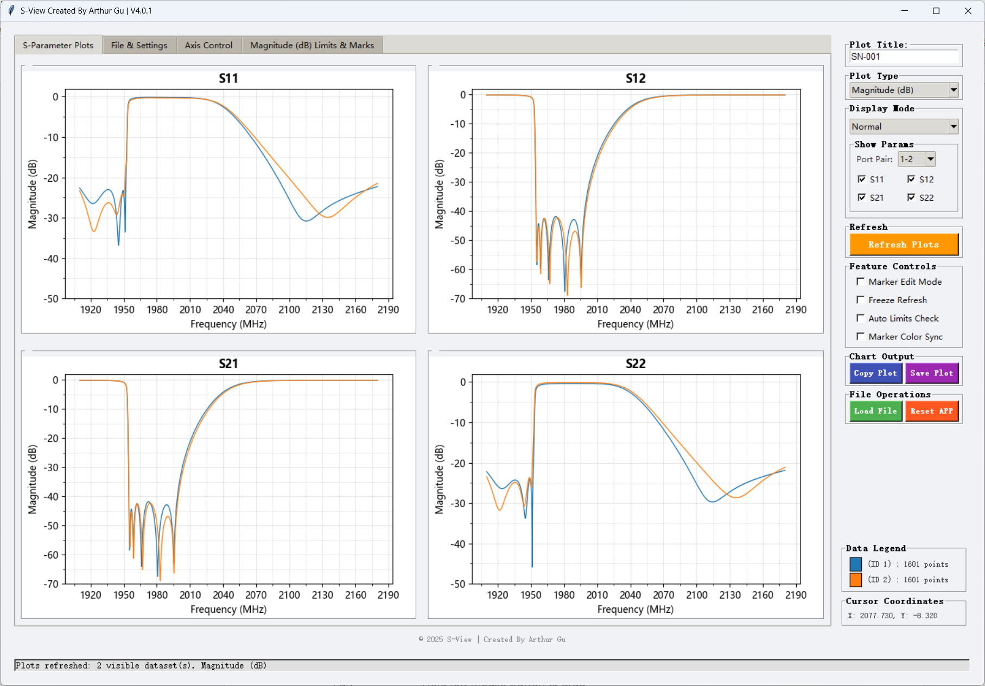

* **Max Mode**: All traces overlaid on one large plot, perfect for fast comparison → Switch via the **Display Mode** dropdown at the top-right

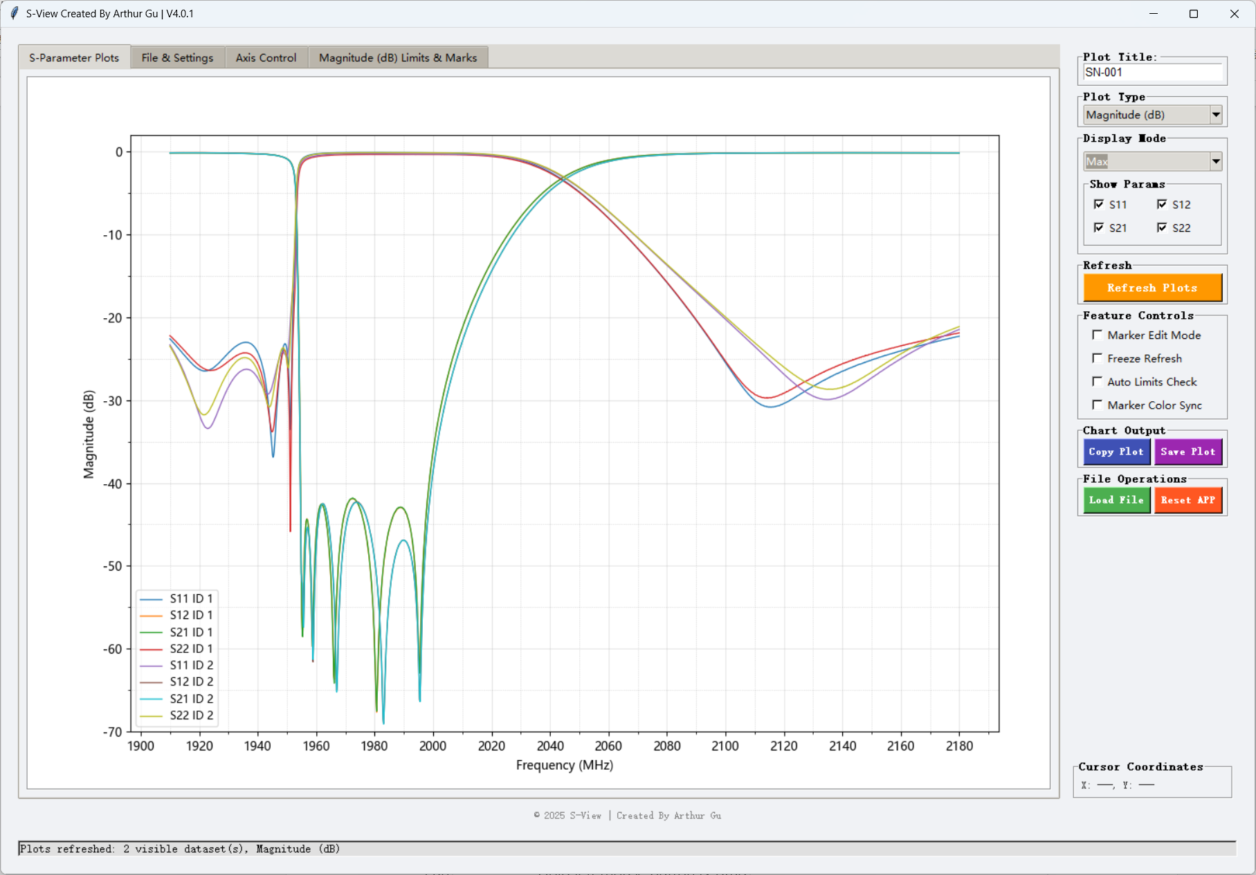

**3.5 Hide/Show Specific S-Params**

In the Show Params, select the checkbox on the right Uncheck → the S-params disappears instantly from the plot (After click Refresh Plots to refresh)

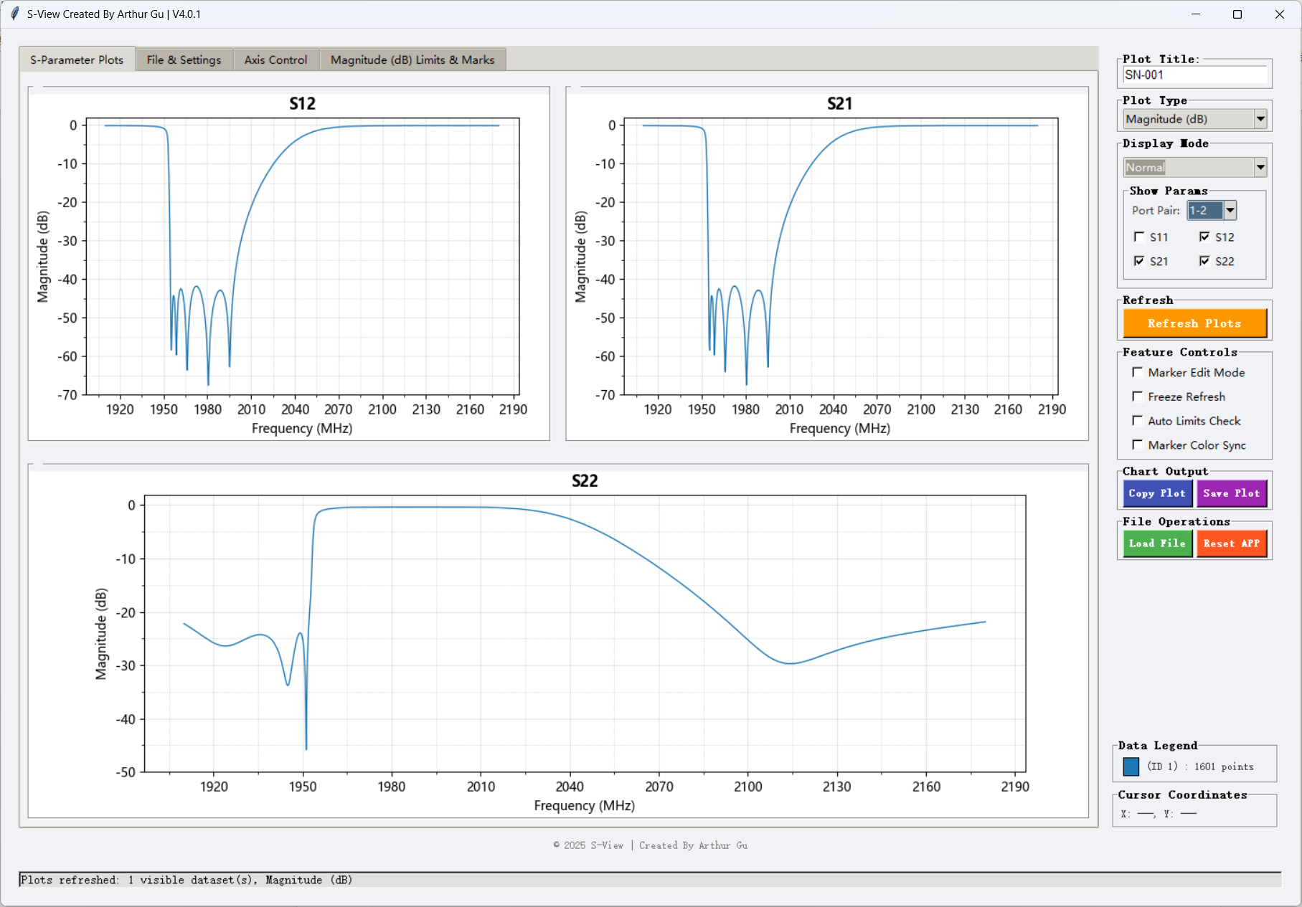

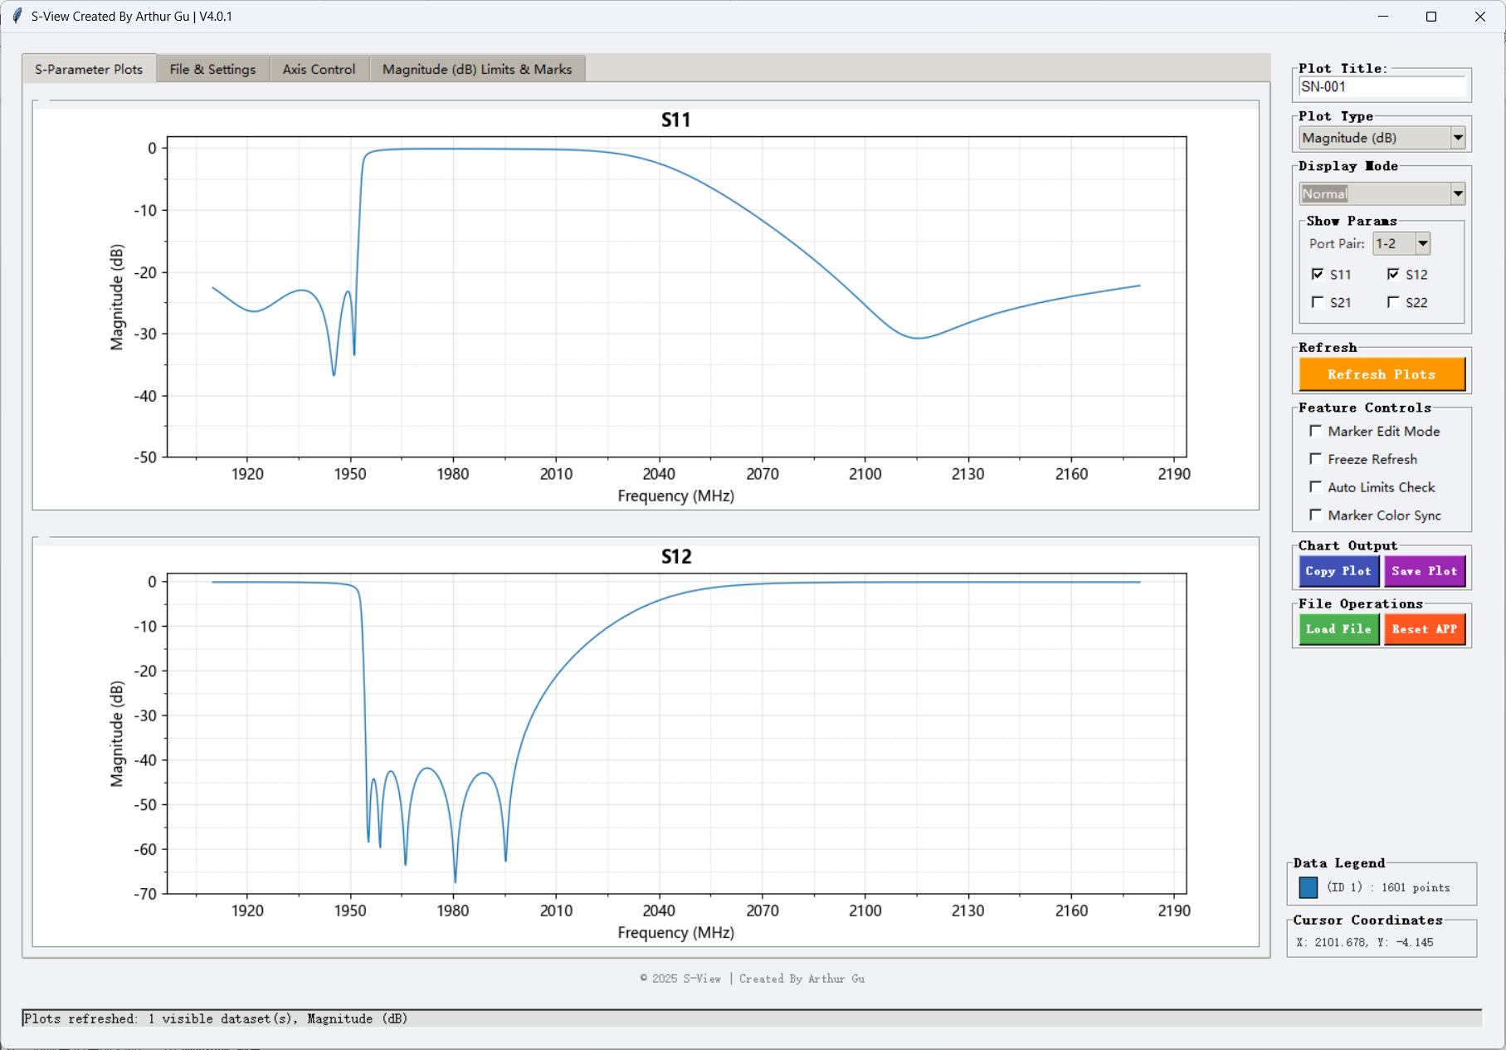

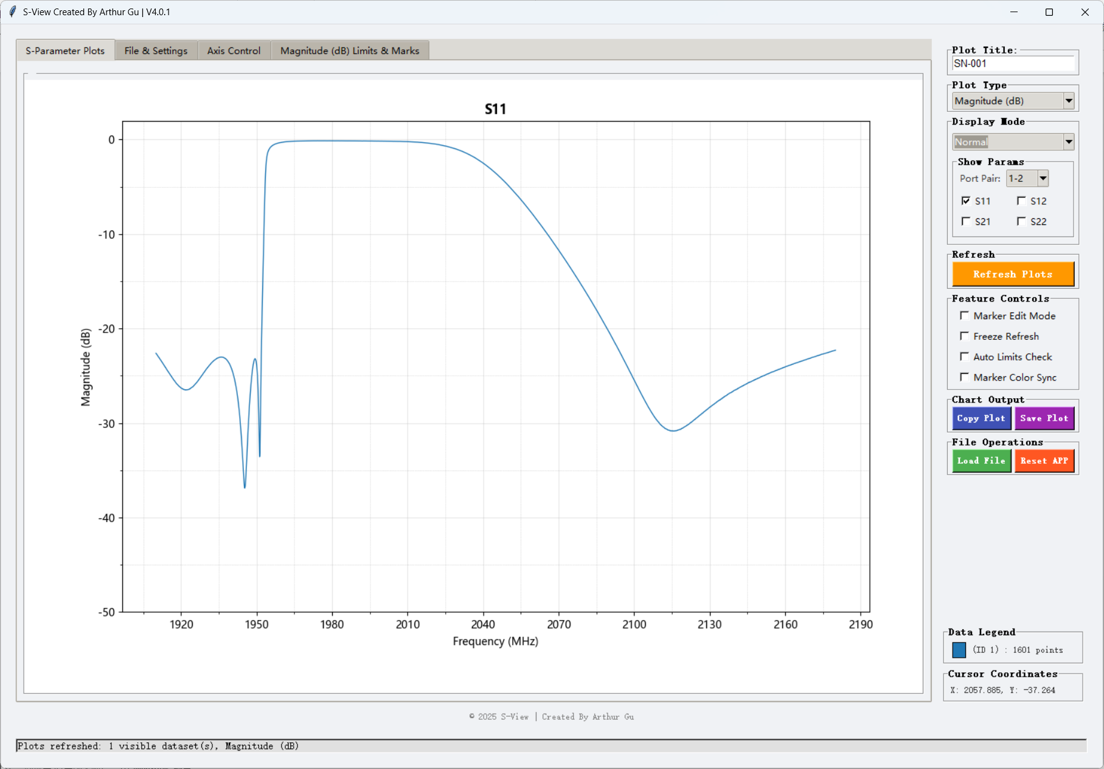

**3.6 Switch Port Pair**

For S3P or S4P you can switch Port Pair in Show Params (Screen automatic to refresh)

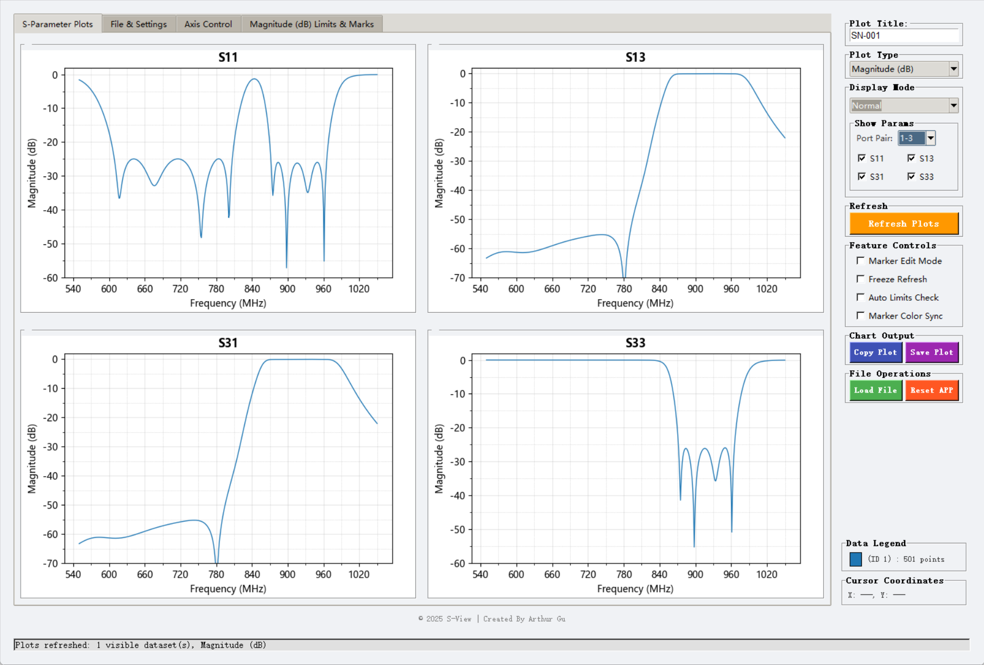

**4. Plot Interaction (All mouse operations)**

|  |  |  |
| --- | --- | --- |
| **Action** | **Method** | **Note** |
| Zoom | Mouse wheel |  |
| Reset Zoom | Click Refresh Plots |  |
| Add Marker | Left-click | Enable Marker Edit Mode |
| Remove Marker | Right-click | Enable Marker Edit Mode |
| Drag Marker | Hold left mouse Left-click & drag | Disable Marker Edit Mode |
| Pan | Hold left mouse Left-click and Right-click botton & drag | Disable Marker Edit Mode |
| Precise reading | Hover over any trace | Real-time frequency & value shown in Cursor Coordinates |

**5. Limit Lines & Marker Functions**

**5.1 Add Limit Lines**

1. **Limits & Marks** tab
2. Select target S-parameter (e.g., S11,S12,S21)
3. → Limit Lines
4. Click **Add Limit Line**
5. Choose type (Upper Limit, Lower Limit)
   1. Upper Limit → straight line
   2. Lower Limit → dot dash line
6. Enter Start/Stop frequencies
7. Enter Upper / Lower values (sloping lines supported)
8. Click **Refresh Plots** to activity the setting

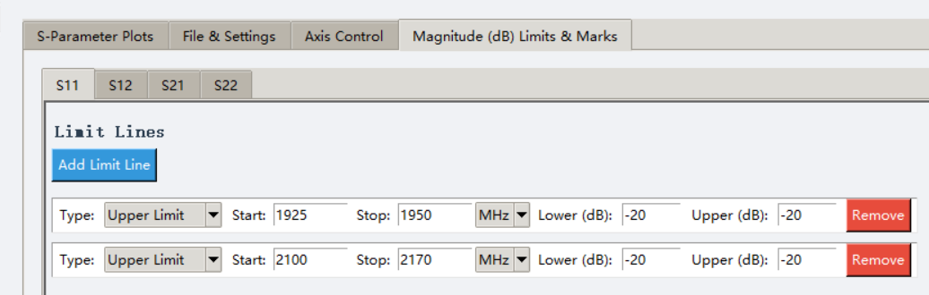

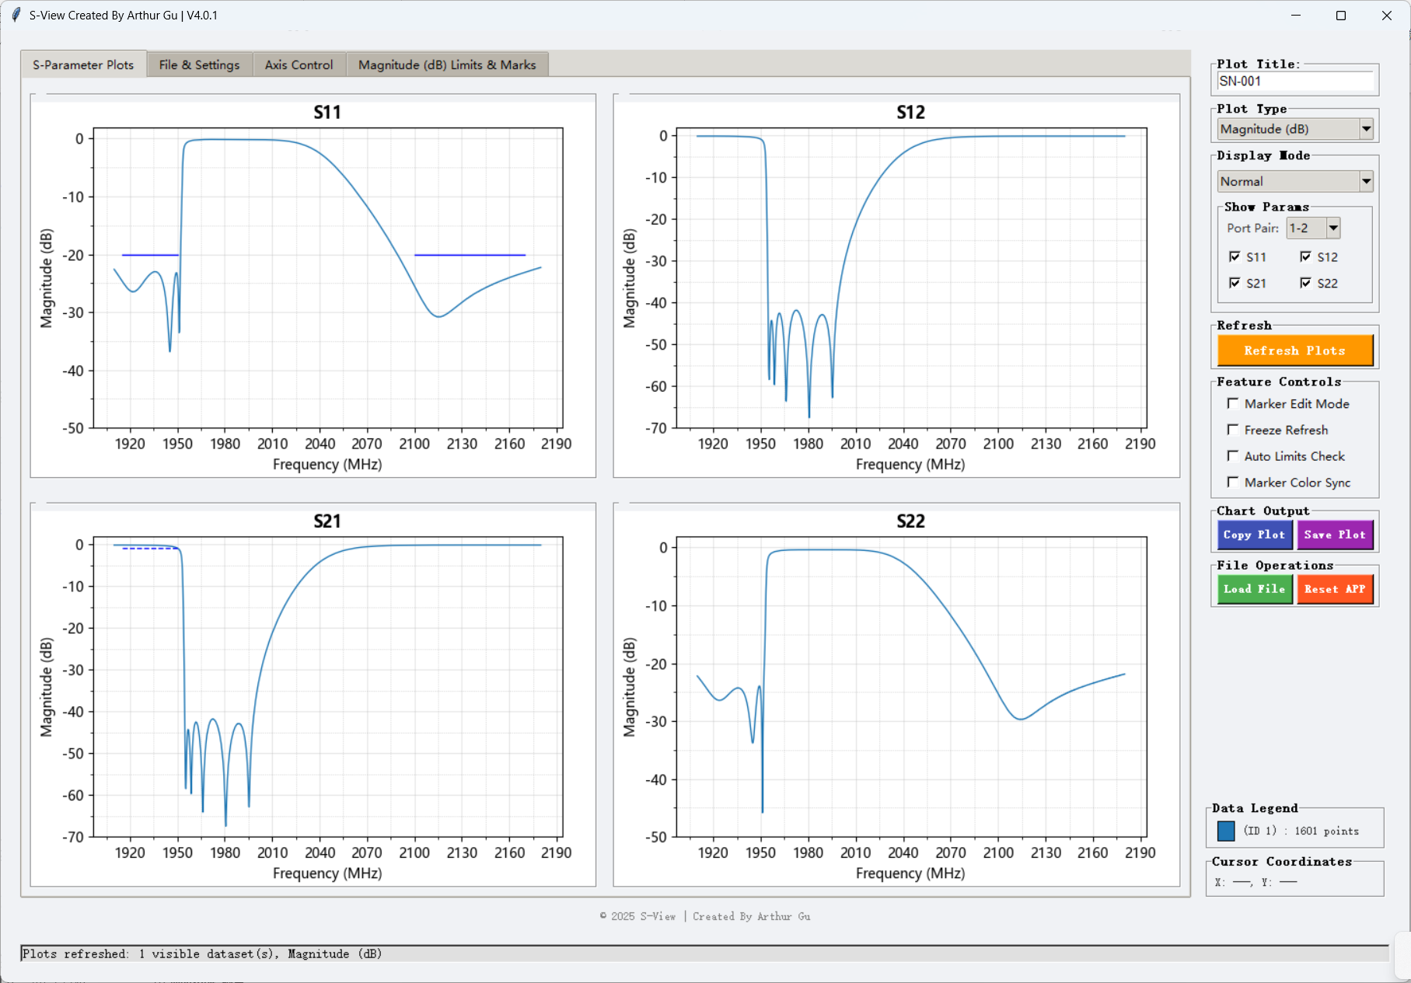

**5.2 Add Regular Markers Manually**

1. Go to **Limits & Marks** tab
2. Select target S-parameter (e.g., S11,S12,S21)
3. → Regular Marker
4. Click **Add Marker**
5. Enter frequency (MHz/GHz)
6. Select Data ID
7. 2nd click creates M2… are created automatically
8. Has Display/Hide Marker feature
9. Click **Refresh Plots** to activity the setting

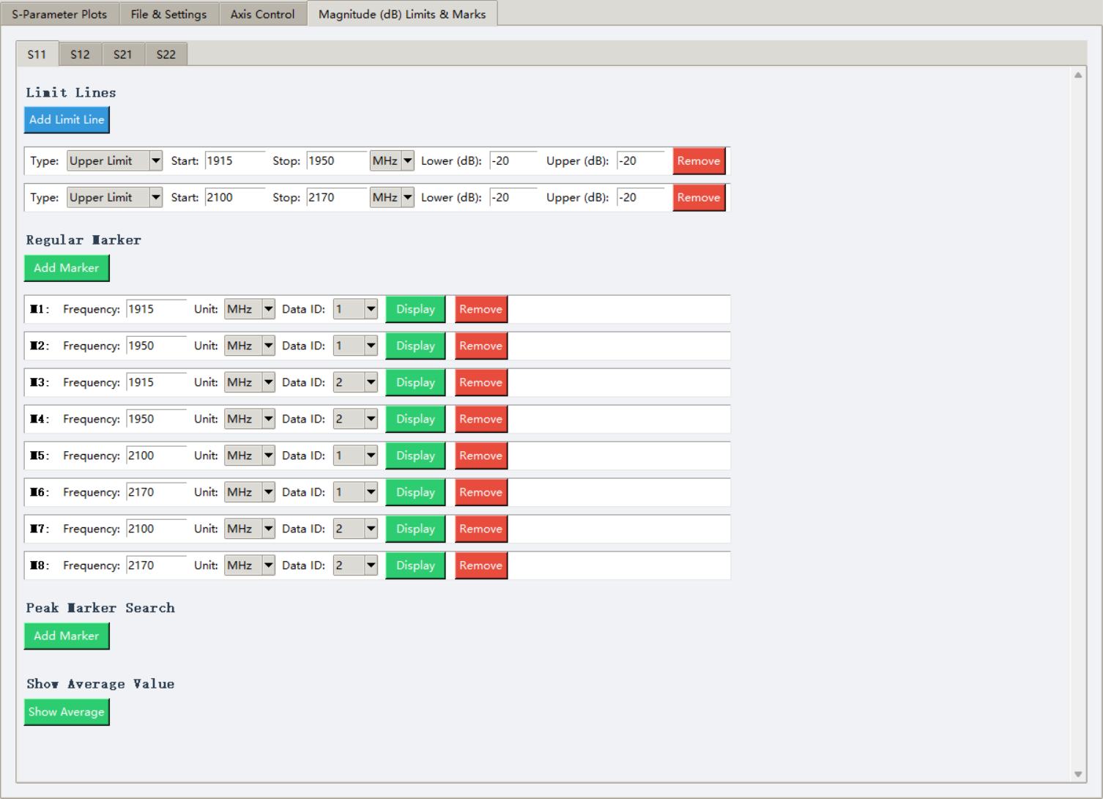

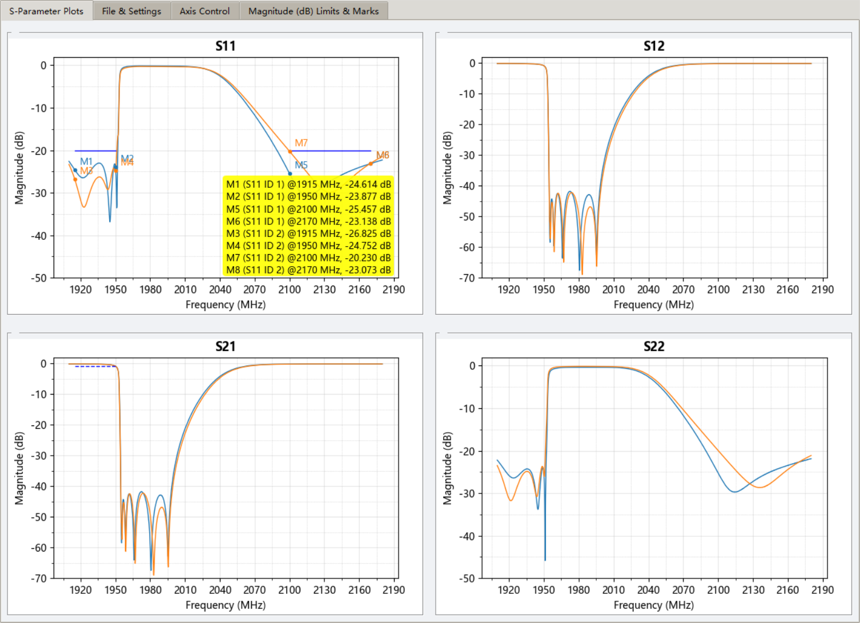

**5.3 Peak Marker Search**

1. Go to **Limits & Marks** tab
2. Select target S-parameter (e.g., S11,S12,S21)
3. → Peak Marker Search
4. Click **Add Marker**
5. Enter Start/Stop frequency (MHz/GHz)
6. Select Data ID
7. Search type:
   * **Max Value** → global maximum
   * **Min Value** → global minimum
   * **Custom Search** → search only in regions exceeding a user-defined threshold
8. Match mode:
   * **First Match** → first peak that meets the condition
   * **Last Match** → last peak that meets the condition
9. 2nd click creates P2… are created automatically
10. Click **Refresh Plots** to activity the setting

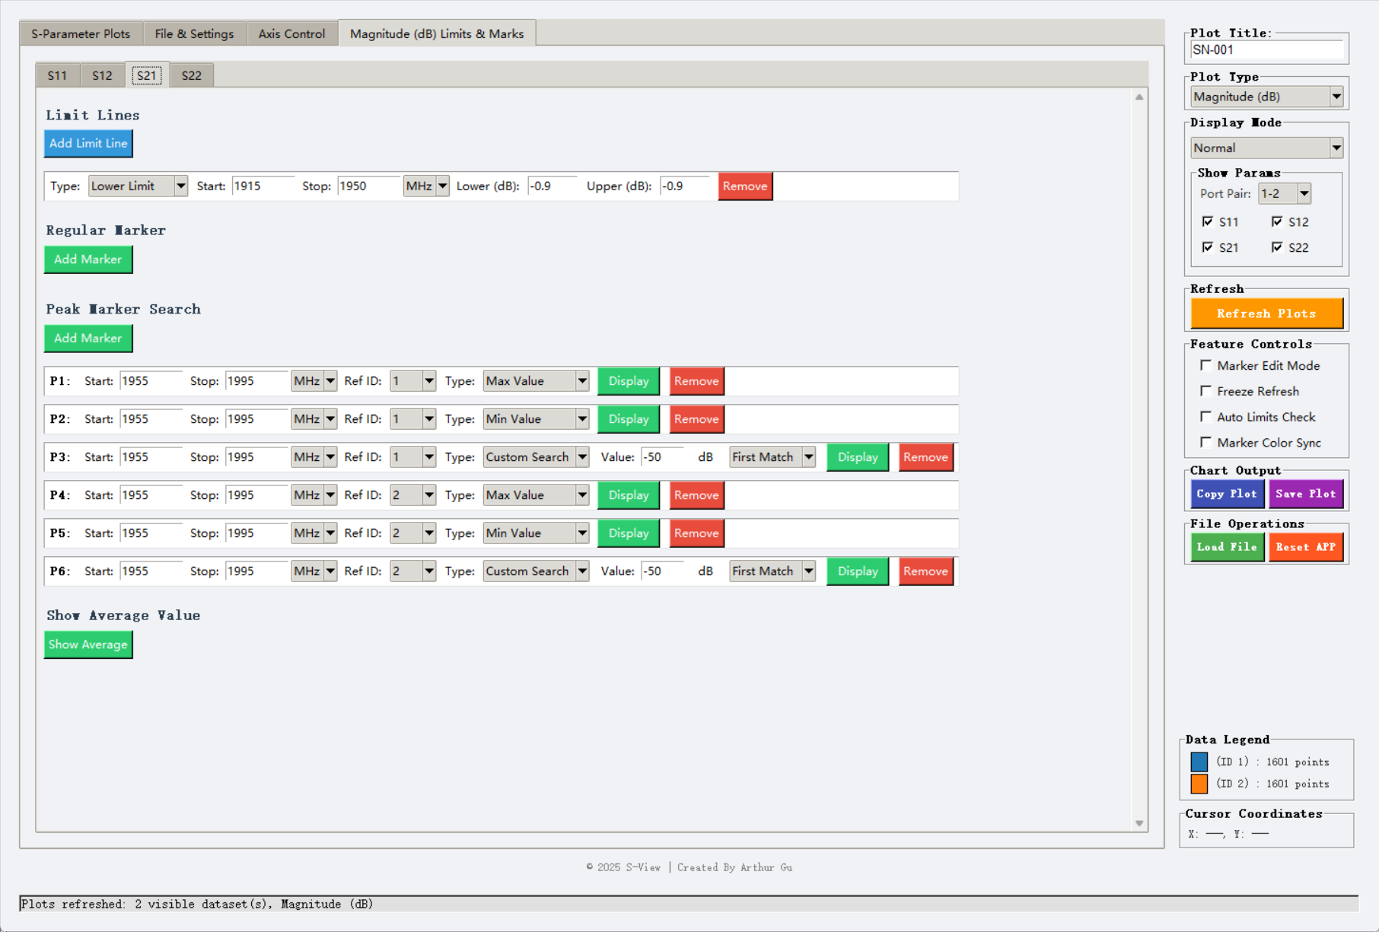

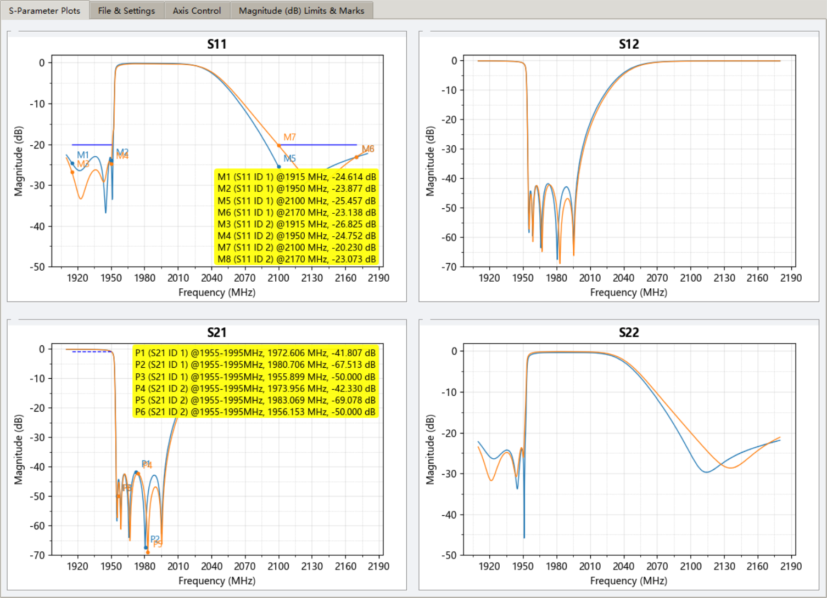

**5.4 Show Average Value**

1. Go to **Limits & Marks** tab
2. Select target S-parameter (e.g., S11,S12,S21)
3. → Show Average Value
4. Click **Show Average**
5. Enter Start/Stop frequency (MHz/GHz)
6. Select Data ID
7. 2nd click creates A2… are created automatically
8. Click **Refresh Plots** to activity the setting

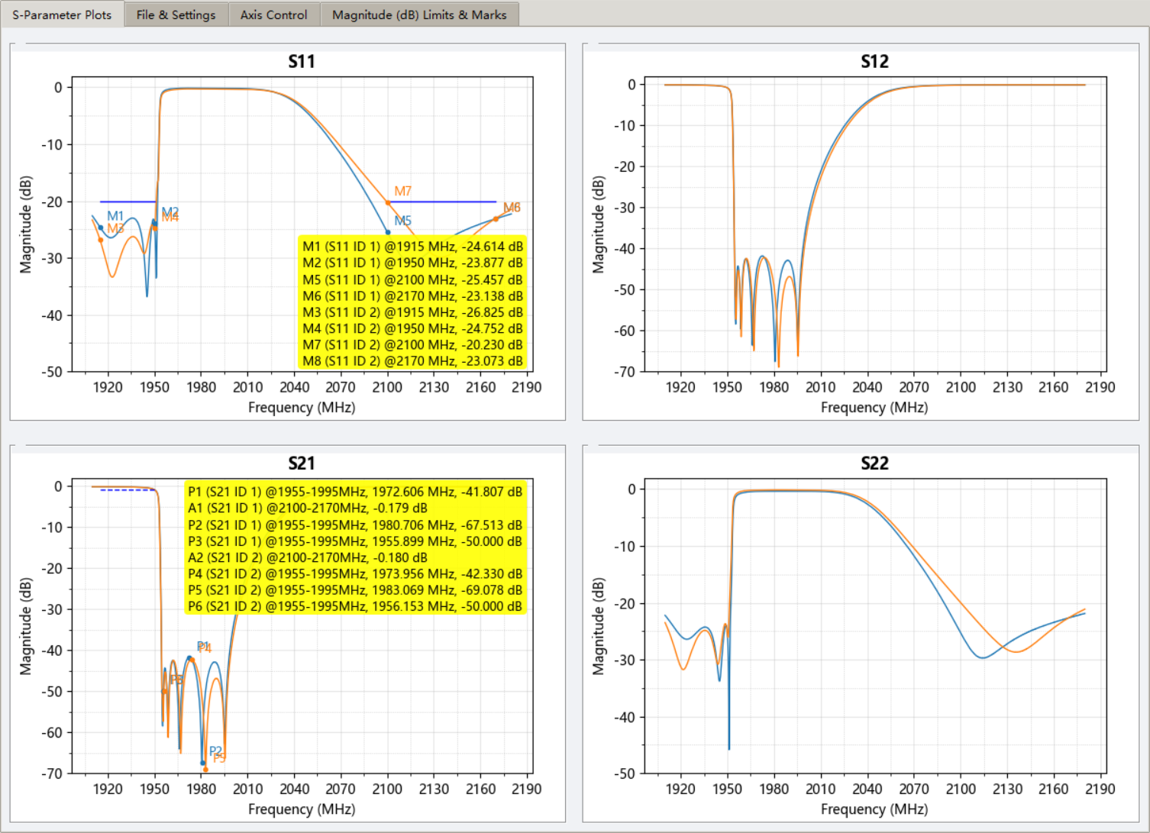

**5.5 Fully Customizable Marker Legend (Yellow Box)**

Location: **File & Settings → Marker Legend Background Customization**

**5.5.1** Background style, face color, and transparency are fully adjustable transparent background

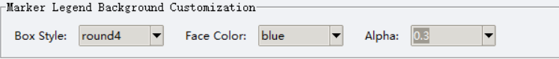

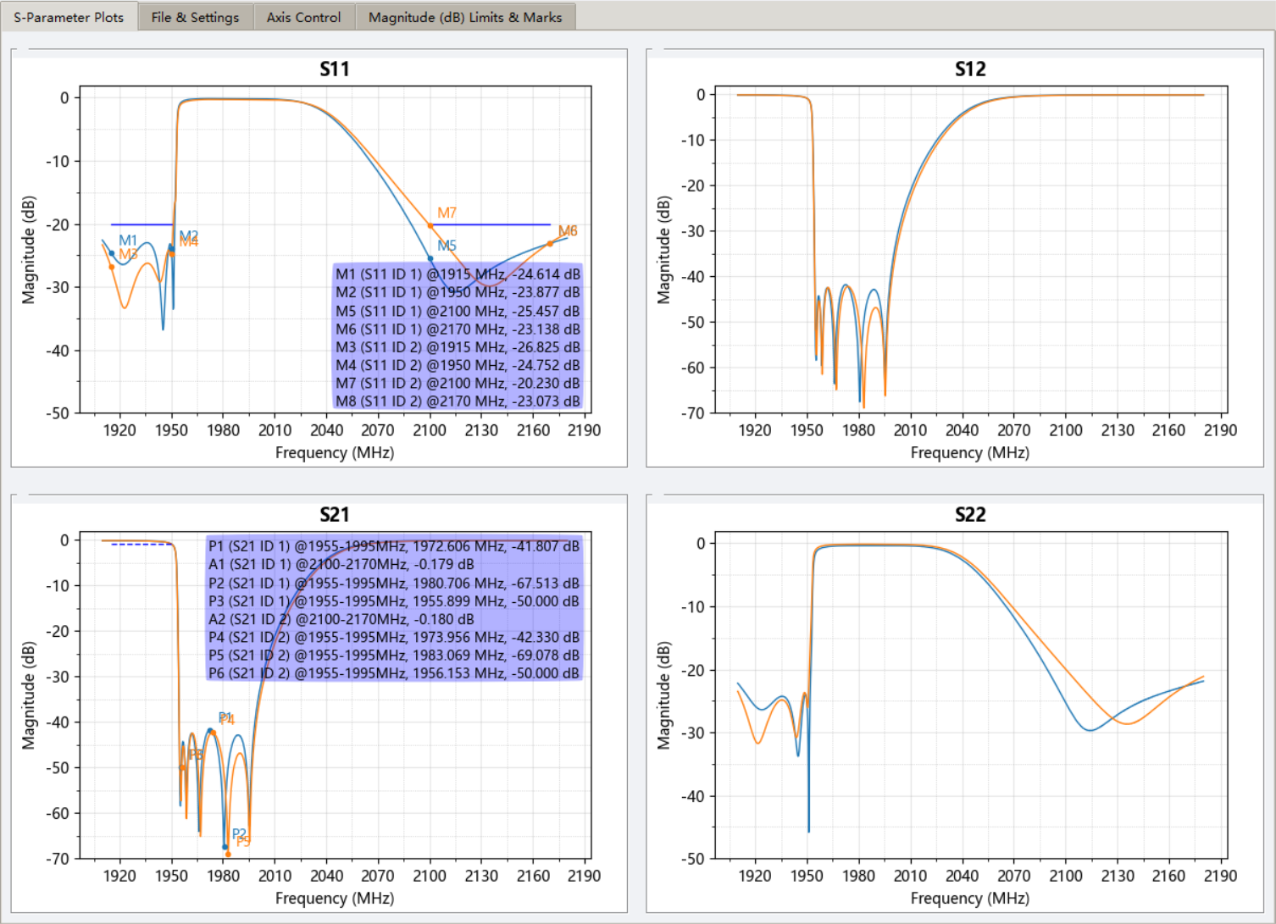

**5.5.2** Check **Marker Color Sync** → Marker Legend color will automatically match to each ID/trace color

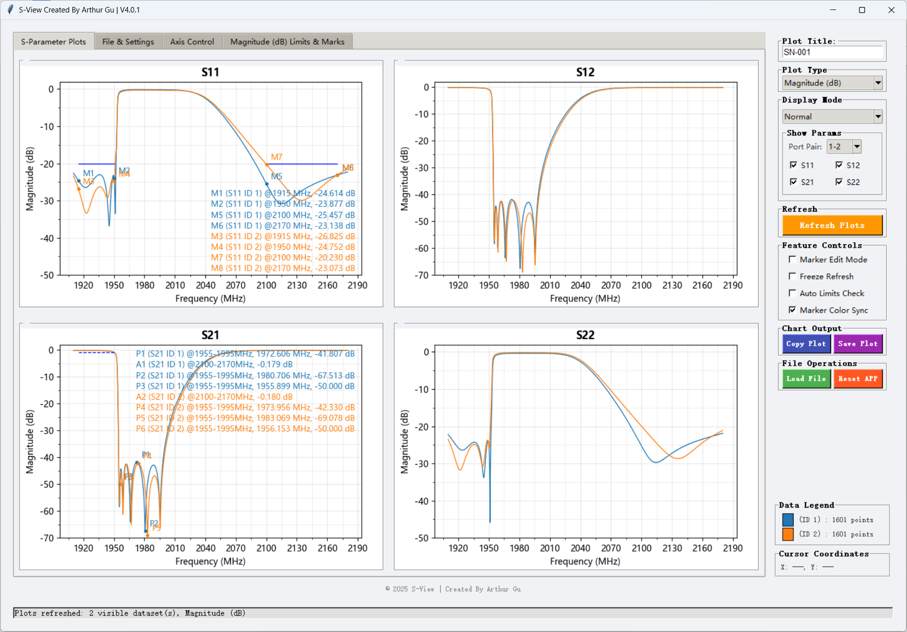

**6. Limit Lines & Automatic PASS/FAIL Check**

Check **Auto Limits Check** (top-left) → Real-time result in lower-right corner of the plot:

* Green = PASS
* Red = FAIL
* Gray = N/A (no limit lines or no frequency overlap)

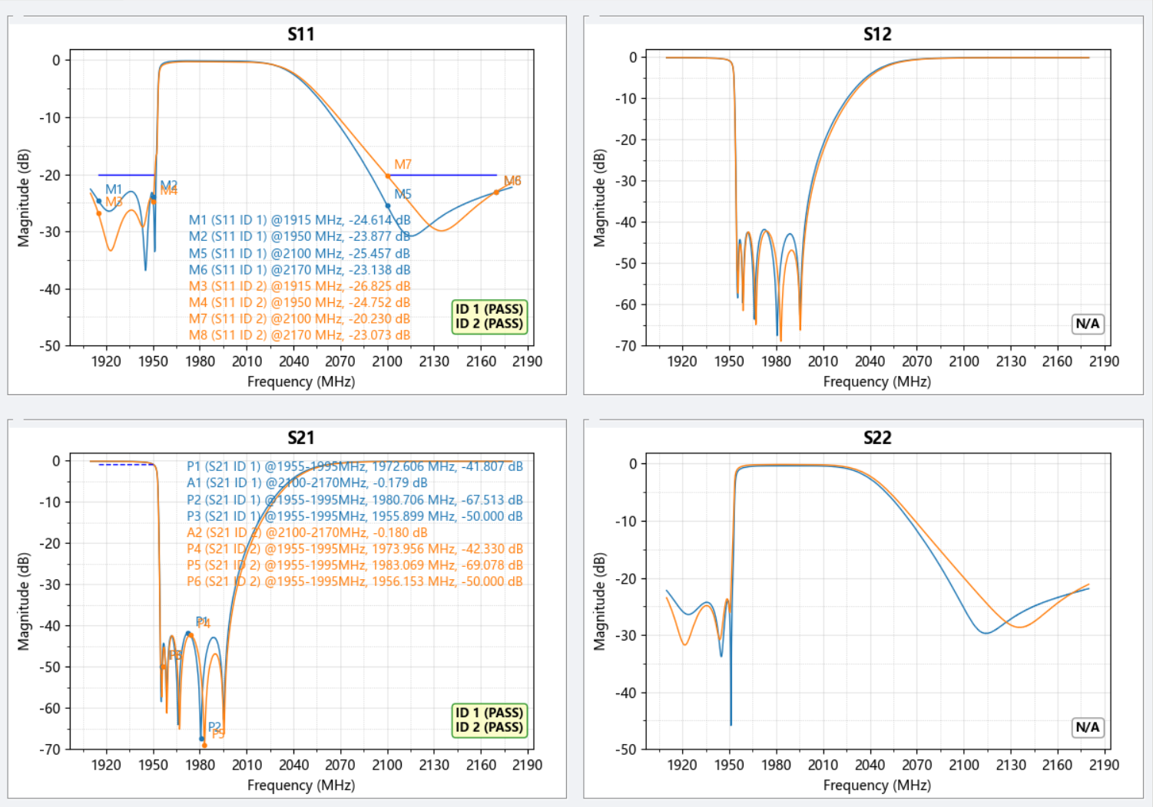

**7. Axis Control**

* **X-axis**: Custom start/stop frequency (MHz/GHz)

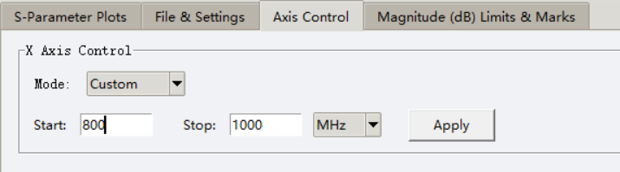

* **Y-axis**: Normal Mode
  + Independent Min/Max for each parameter
  + Click **Refresh Plots** to activity the setting

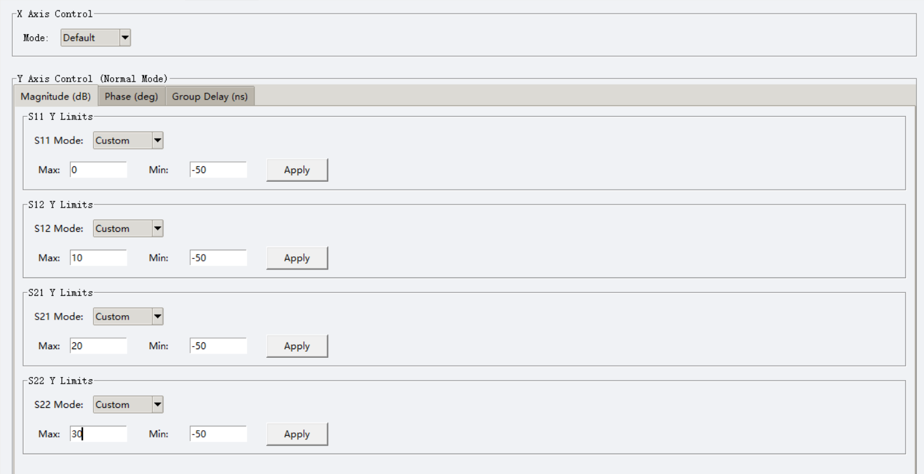

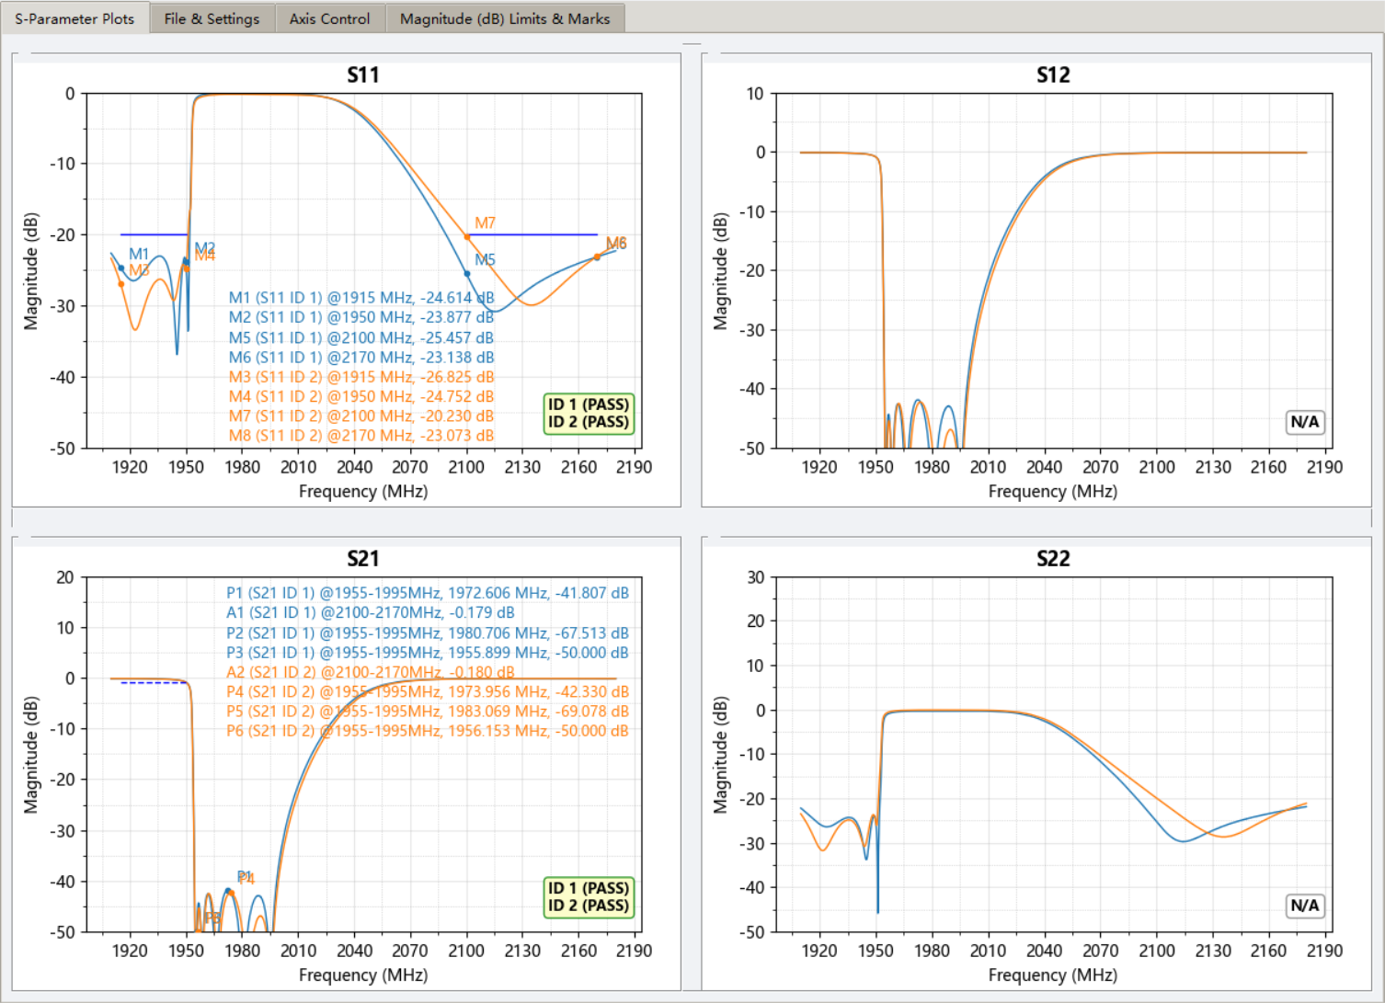

* **Y-axis**: Max Mode
  + Unified Min/Max for all traces
  + Click **Refresh Plots** to activity the setting

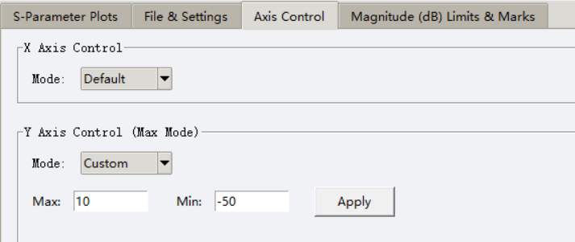

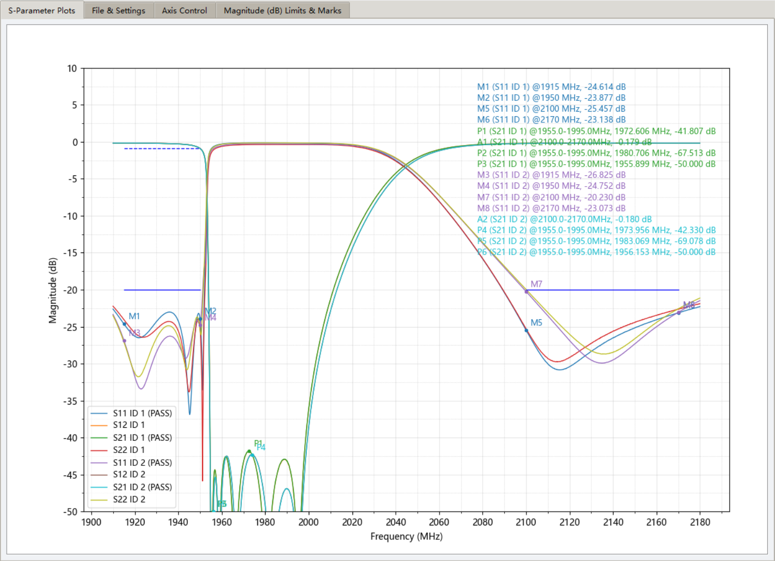

**8. Full Trace Color Customization (Supports 16 traces in S4P)**

1. Click the **🎨** button in the file list

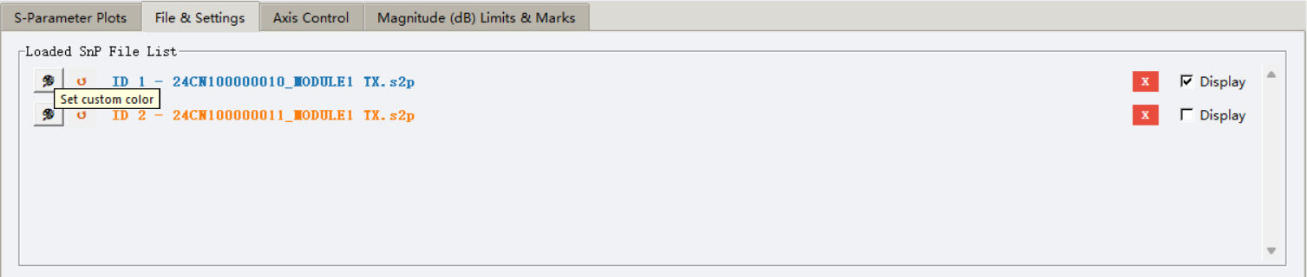

1. Normal mode: set one color for the entire file
2. Max mode: dedicated window opens
   * S2P → 4 traces
   * S3P → 9 traces
   * S4P → 16 traces (automatic two-column layout) Every single S-parameter can have its own color

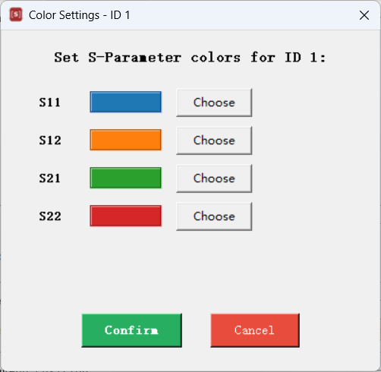

Click the **↺** button to instantly restore default color cycle

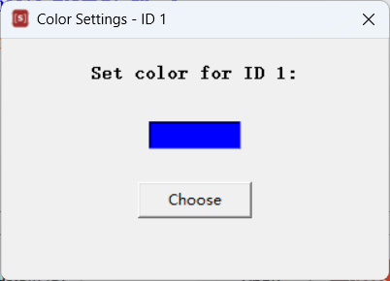

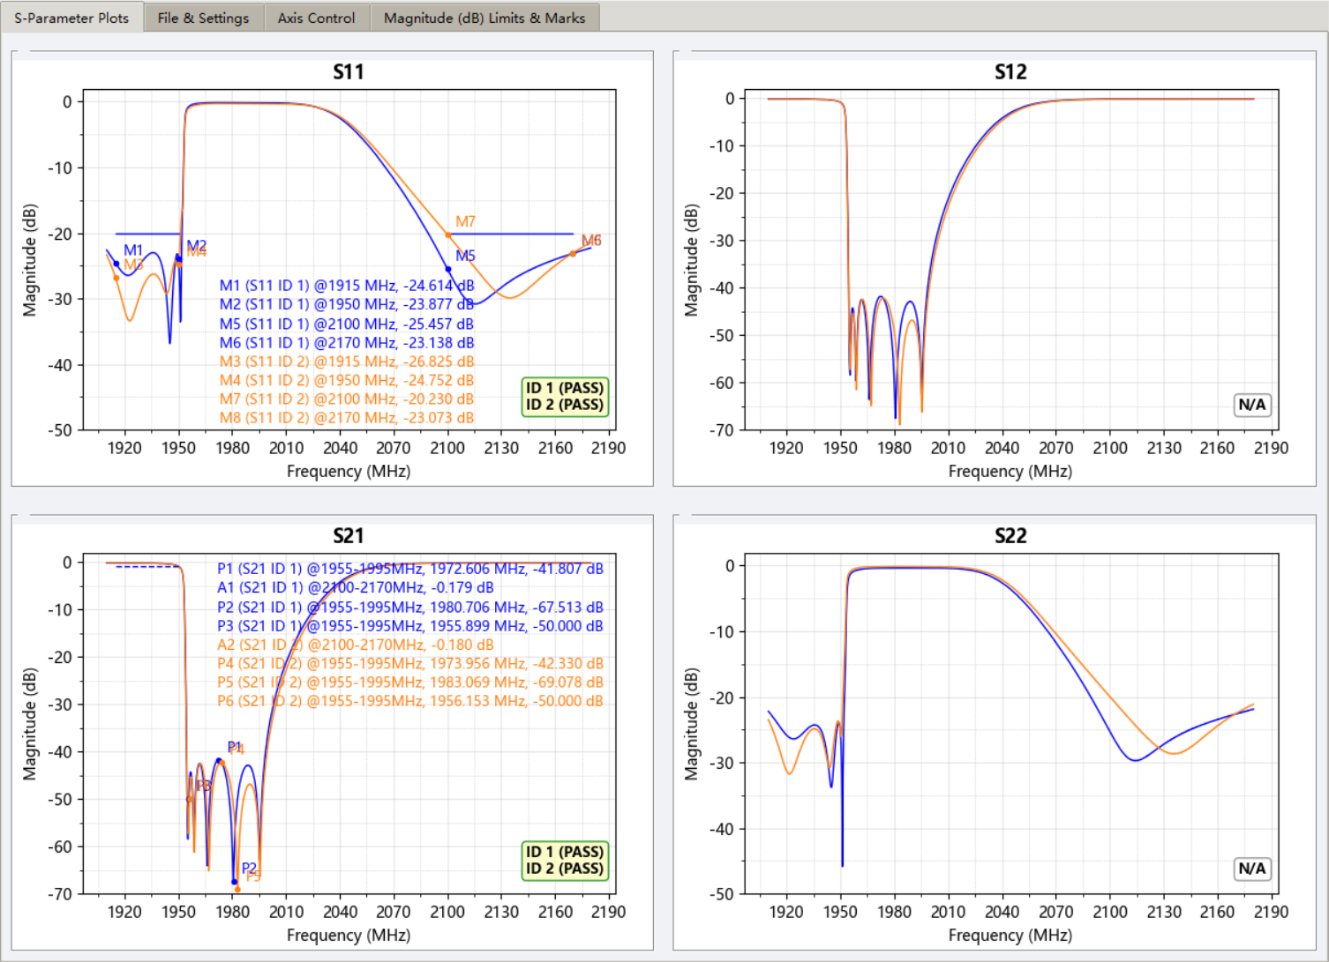

**9. Hide Load trace**

Select or unselect the Display feature to show or hide the load file.

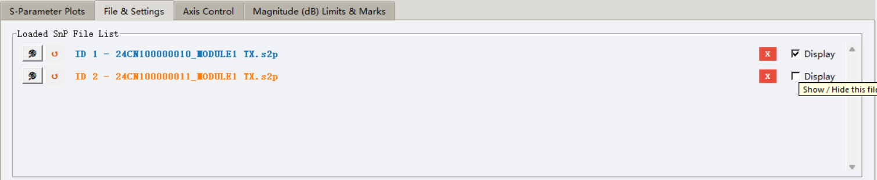

**10. Custom File Names (Replace long paths with meaningful names)**

**File & Settings → Customize File Name**

1. Select ID from dropdown
2. Type desired name (e.g., “Device A”)
3. Click **Set Name** → All legends, markers, and file list now show the new name
4. Click **Refresh Plots** to activity the setting

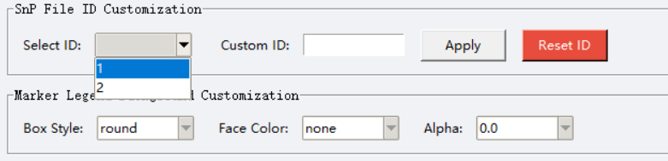 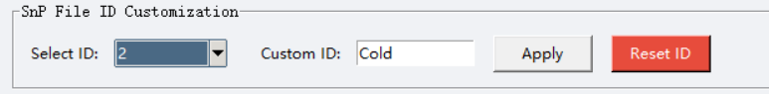

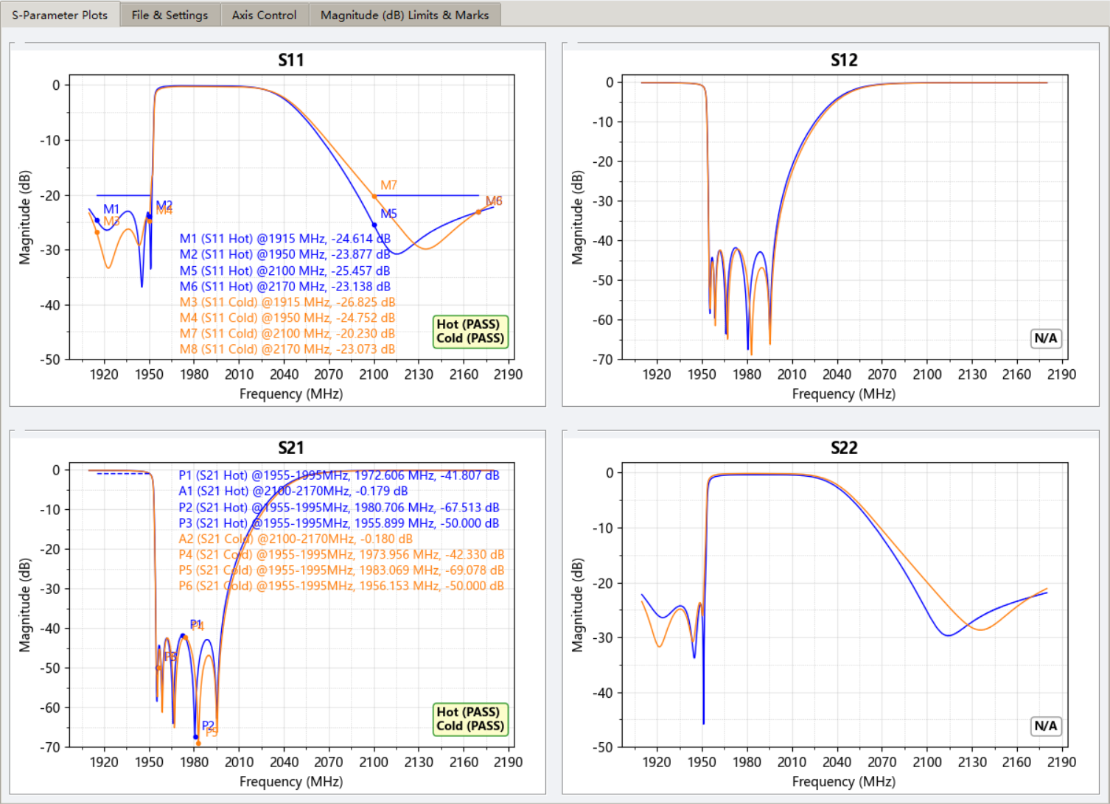

**11. Marker Legend Position**

**File & Settings → Marker Legend Position**

* Normal Mode
  + Independent for each parameter
  + Click **Refresh Plots** to apply the setting

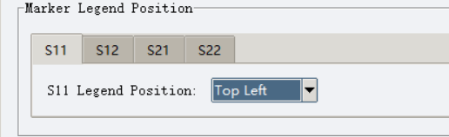

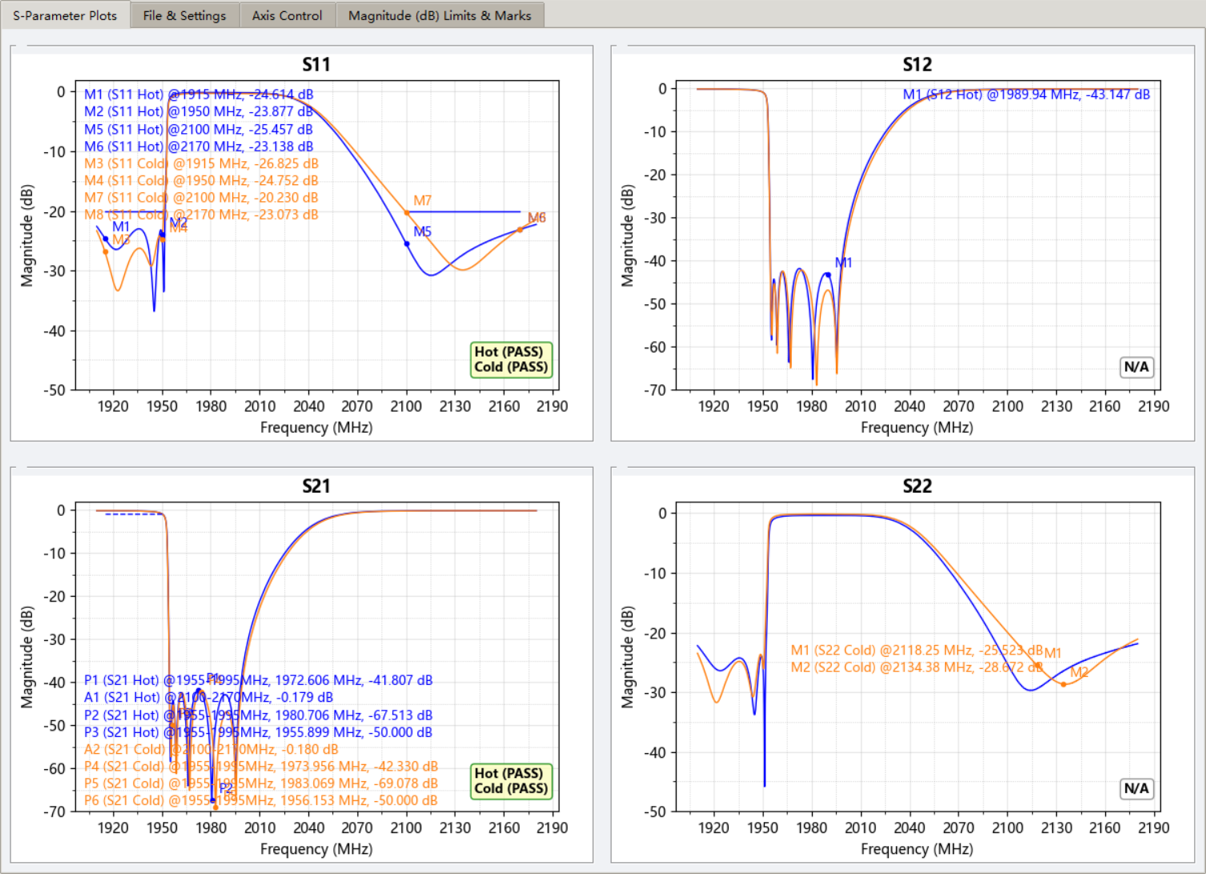

* Max Mode
  + For all traces
  + Click **Refresh Plots** to activity the setting

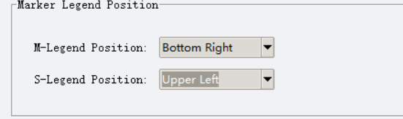

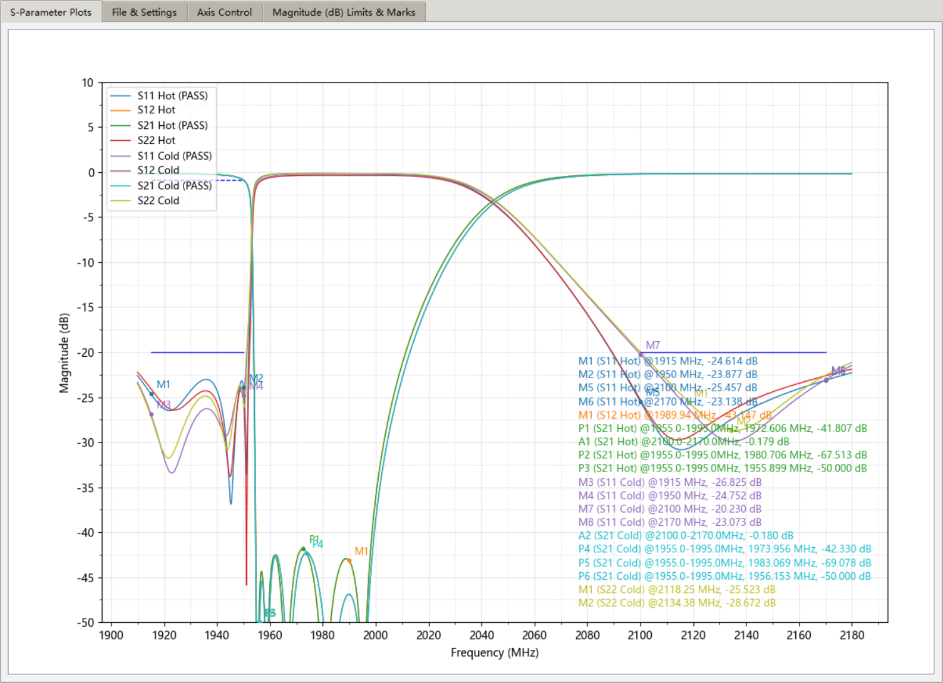

**12. Drag Marker Legend Position**

* Disable Marker Edit Mod Feature

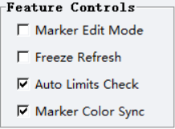

* Hold left mouse Left-click & drag
* In File & Settings the Marker Legend Position will change to Custom automatically
  + Normal Mode

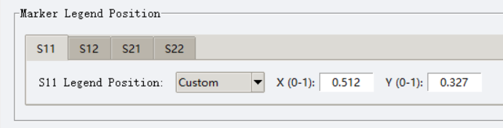

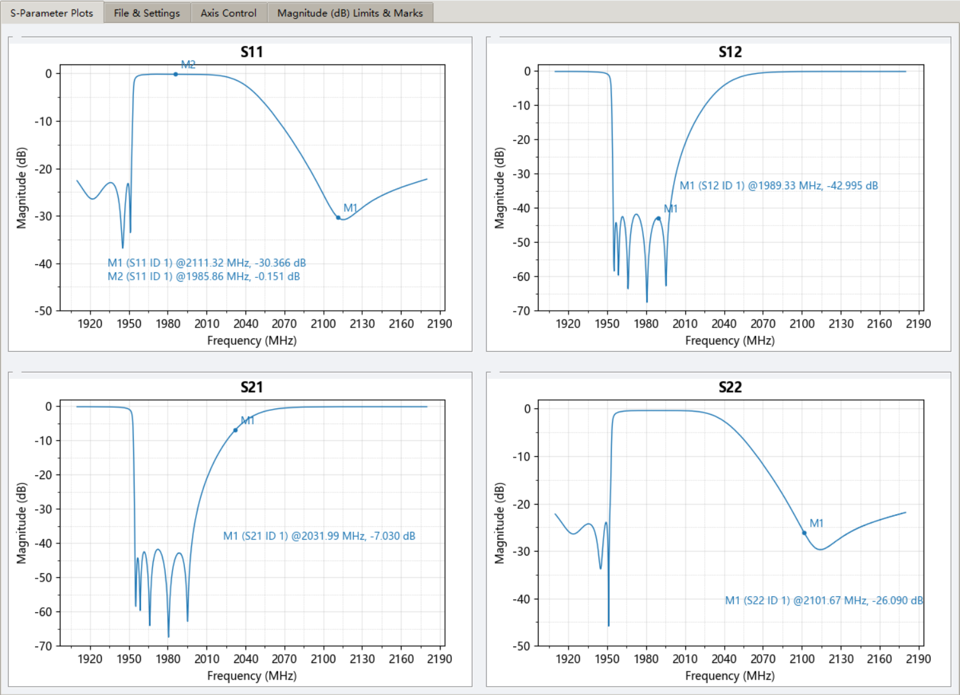

* + Max Mode

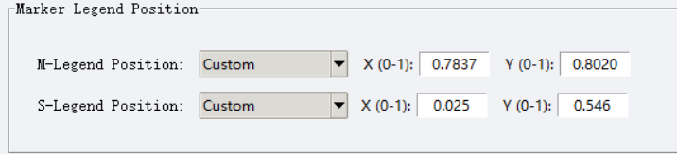

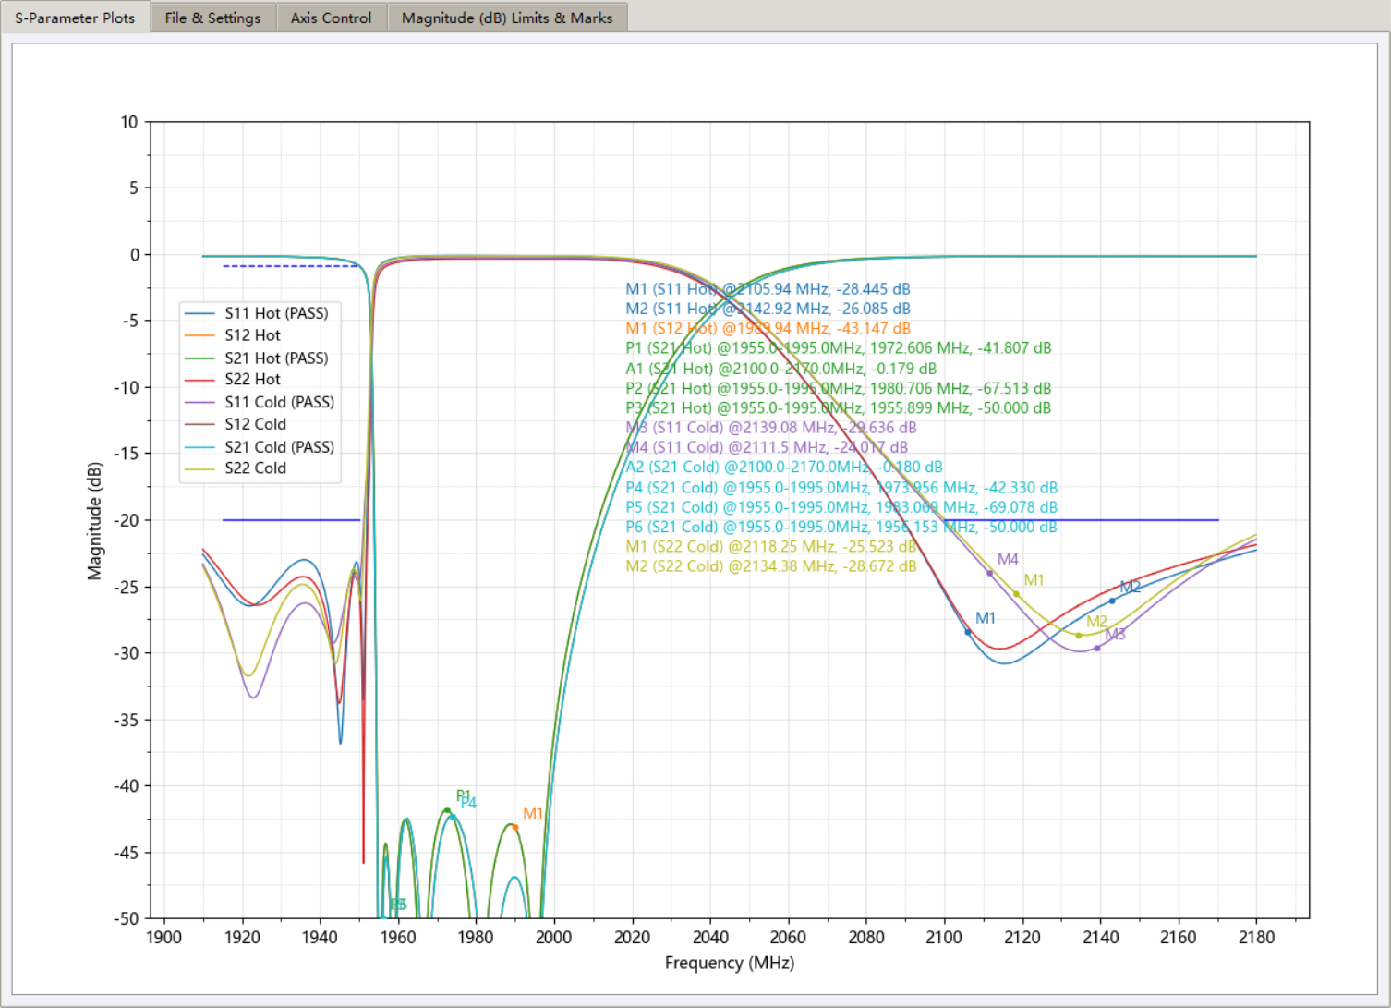

**13. Add/Remove Marker by Mouse**

* Enable Marker Edit Mod Feature

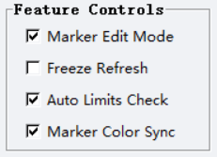

* Left-Click on screen to add Marker

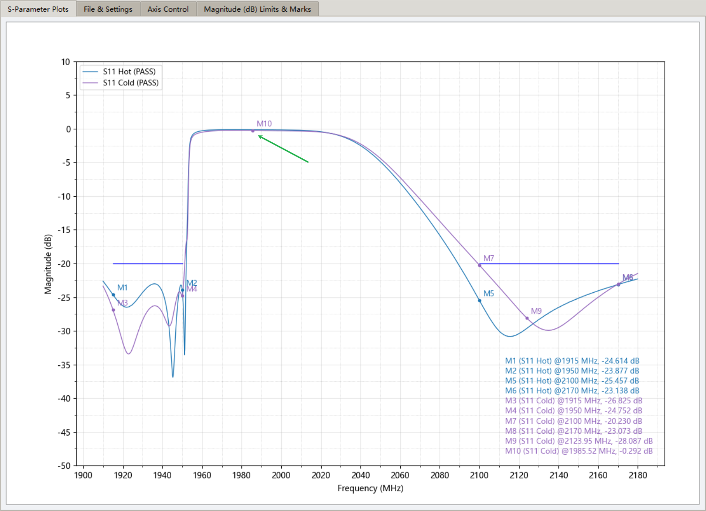

* Right-Click on screen to Remove Marker

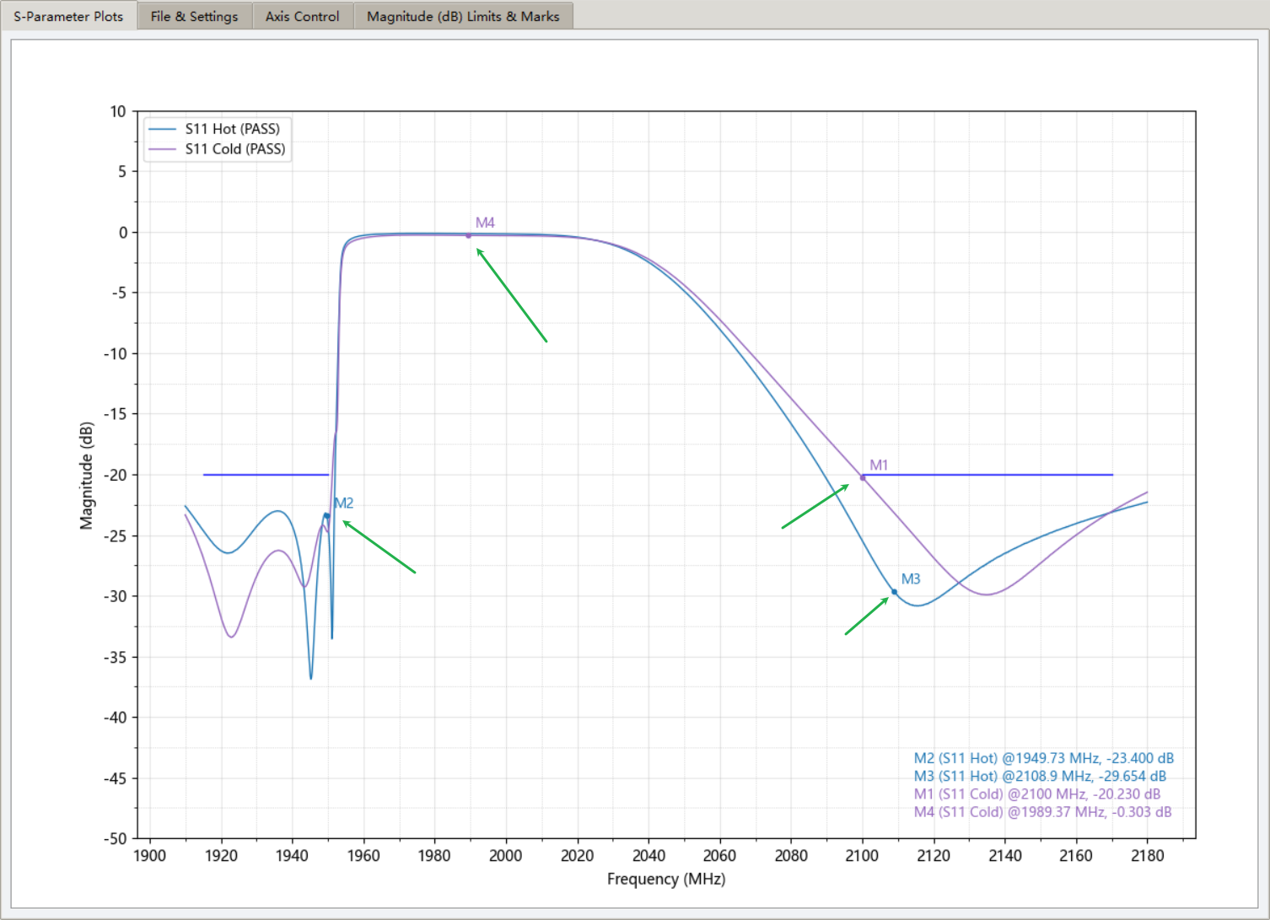

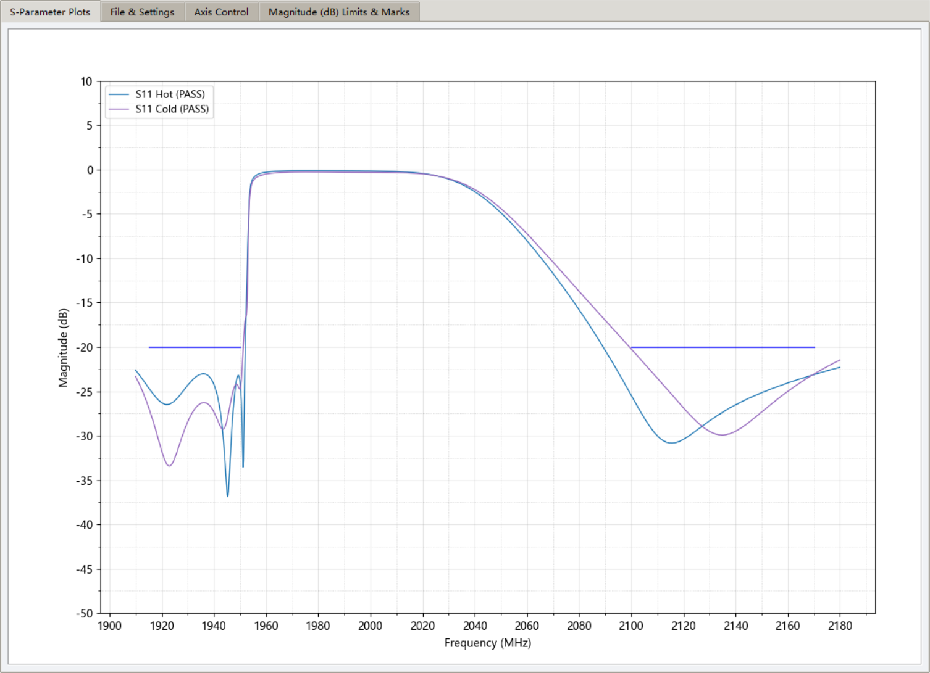

**14. Freeze Refresh**

* Enable Freeze Refresh

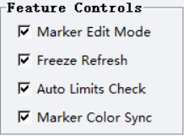

This feature allows you to add/remove marker by mouse left/right click without refresh after zoom the screen

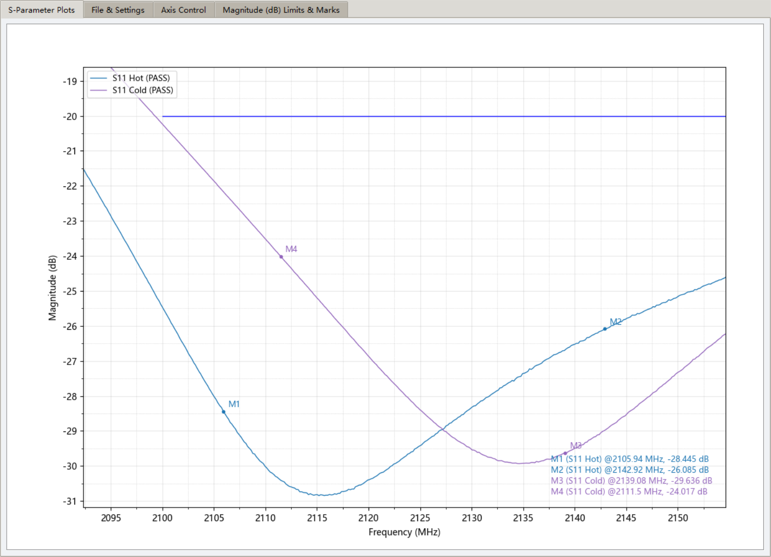

**15. Report Export**

* Copy Plot
  + Plot copy to clipboard

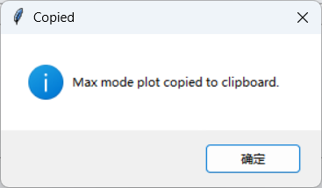

* Save Plot
  + Supports PNG / PDF

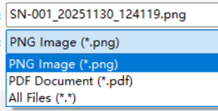

* Add company logo (negative offset supported for precise corner placement)

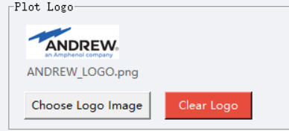

* Custom report title (e.g., “SN-001”)

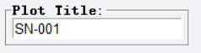

* Exported images automatically by file IDs – in Normal Mode

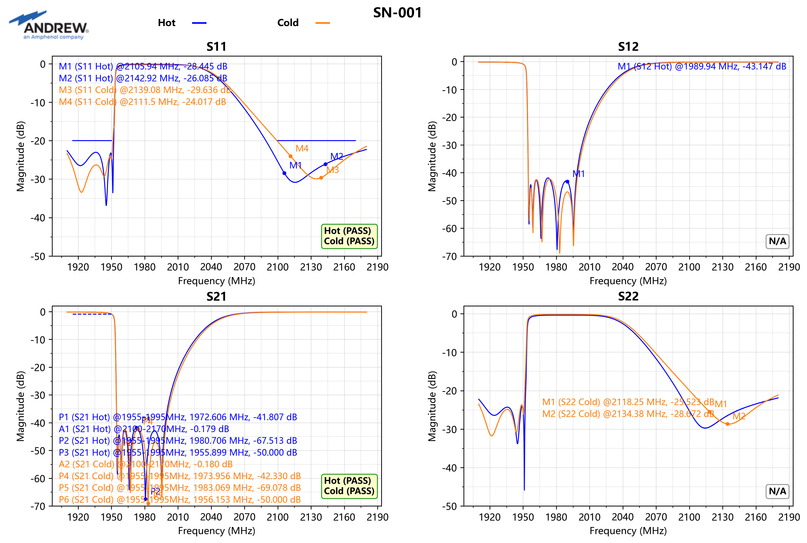

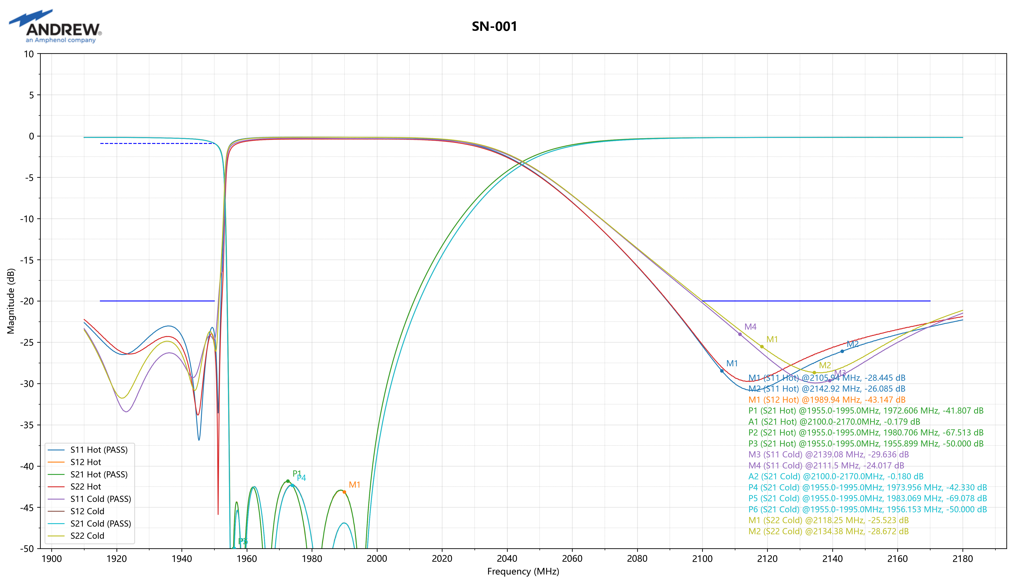

**16. Reset App**

* Wipe all files and reset to its initial state



**17. Tips**

* **Smoothest Marker Legend Dragging** → Check Freeze Refresh → drag yellow box → release → coordinates saved automatically
* **Quickly compare two batches** → Load both sets → Max mode → assign different colors → zoom to region of interest
* **Find multiple resonances instantly** → Click Add Peak Marker 5 times → M1–M5 created automatically
* **View all 16 S-parameters at once** → Load .s4p → switch to Max mode → all traces overlaid
* **Never lose your zoom** → All operations (add markers, edit limit lines) keep current zoom when Freeze Refresh is enabled